- Pick any two favorite websites or apps you use (like Instagram, Zomato, or Myntra). Use the MozBar Chrome extension to check and compare their Domain Authority (DA) and Page Authority (PA) for their homepages. Write down both values for each and explain in 2-3 lines what the difference between DA and PA means for these sites.
Website | Homepage | DA | PA
Instagram | instagram.com | 99 | 98
Zomato | zomato.com | 91 | 78

DA (Domain Authority): Puri website ki strength batata hai.
PA (Page Authority): Kisi ek page, jaise homepage, ki strength batata hai.

- Find three real backlinks pointing to Flipkart.com using the free version of Ahrefs Backlink Checker or Moz Link Explorer. For each backlink, note whether it is DoFollow or NoFollow and write one line about why a DoFollow backlink is more valuable for SEO.

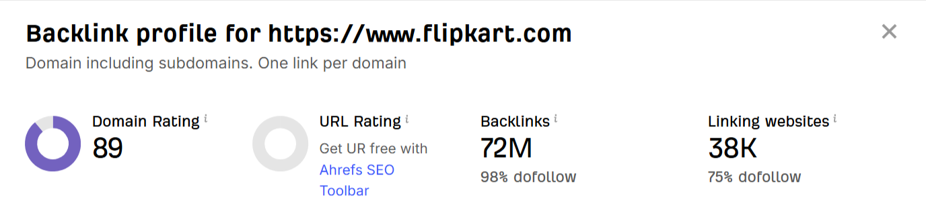
DoFollow backlinks are more valuable because they can pass SEO authority from one website to another and may help improve search rankings.
NoFollow = generally SEO authority pass nahi karta
- Create a simple table comparing Trust Flow, Citation Flow, and Domain Rating for any one popular Indian app website (for example, bookmyshow.com) using the free tools from Majestic and Ahrefs. List the three metrics and in one line each, describe what each metric indicates about the website's authority.
Metric | Value | Simple meaning
Trust Flow (TF) | 42 | Backlinks ki quality/trust batata hai. Higher TF = more trusted links.
Citation Flow (CF) | 51 | Website ko milne wale backlinks ki quantity/power batata hai. Higher CF = more link influence.
Domain Rating (DR) | 78 | Ahrefs ke according website ke overall backlink profile ki strength batata hai, 0–100 scale par.
- Imagine you are promoting a new music playlist app. List three specific off-page SEO activities you would do to build quality backlinks and improve the app website’s authority. For each activity, mention the type of site or platform you would target (for example, music blogs, YouTube channels, or tech forums).
Activity | Target Platform | What I would do
Guest Posting | Music Blogs | Write useful articles about music and add a link to the app website.
Influencer Collaboration | YouTube Channels | Ask music YouTubers to review/demo the app and include the website link in the description.
Community Promotion | Tech & Music Forums | Participate in relevant discussions and share the app when it genuinely helps users.

- Use ChatGPT or Google Bard to generate a list of five creative ways to earn DoFollow backlinks for a new food delivery app website. Copy-paste the AI’s suggestions, then pick your favorite and explain why you think it would work best for a startup.

AI-generated suggestions:
- Food Blogger Reviews – Give food bloggers access to the app and ask them to review it with a link to your website.
- Local Restaurant Partnerships – Partner with restaurants and ask them to mention your app on their websites.
- Guest Posts – Write useful food-related articles for food and lifestyle websites and include a link to your app.
- Food Influencer Collaboration – Work with food influencers who have blogs/websites and get a backlink from their content.
- Create Food Guides – Make useful guides like “10 Best Restaurants in Ahmedabad” and encourage restaurants to share and link to the guide.
I think food blogger reviews would work best for a startup because they can provide backlinks + brand awareness + potential customers at the same time. It is also easier for a new startup to approach smaller local food bloggers than large websites.

